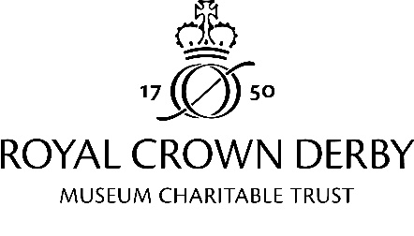
Full terms of submission of content for the Pattern of Life
The Royal Crown Derby Museum Charitable Trust very much hopes to be able to use your contribution but cannot guarantee to do so.
By submitting your contribution to The Royal Crown Derby Museum Charitable Trust you allow them to use the material in your contribution in any way they may reasonably choose on a free-of-charge basis in any media.
You grant The Royal Crown Derby Museum Charitable Trust the right to edit your contribution for operational and editorial reasons – specifically but not limited to the creation of a new piece combining some or all of your contribution with those of others. The Royal Crown Derby Museum Charitable Trust may also share your contribution, individually or as part of the new combined piece with trusted third parties, for instance with Royal Crown Derby ltd.
Any copyright in your contribution will remain with you and this permission is not exclusive, so you can continue to use the material you contribute in any way including allowing others to use it. The copyright in the new combined piece remains with The Royal Crown Derby Museum Charitable Trust and your right to use, share and deal in that combined piece shall be the same as with any other Royal Crown Derby Museum Charitable Trust output.
You confirm that your contribution is your own original work, is not defamatory or unlawful and does not infringe anyone else's rights (including privacy rights). You also confirm that your contribution is made in your personal (rather than business) capacity. You also confirm that you have the consent of anyone who is identifiable in your contribution.
The Royal Crown Derby Museum Charitable Trust may need to contact you for administrative or verification purposes in relation to your contribution, or in relation to particular projects.
The Royal Crown Derby Museum Charitable Trust will ask you to provide some personal information as part of the submission process. The Royal Crown Derby Museum Charitable Trust will keep your personal information secure and will only use it for the purposes of delivery of The Pattern of Life. All personal information held by The Royal Crown Derby Museum Charitable Trust will be held in accordance with the terms of applicable data protection laws.
If you do not want to grant The Royal Crown Derby Museum Charitable Trust permission to use your contributions in accordance with these Terms, please do not share with or submit them to us.
Created 25/11/2020

